1. History of AI

* first used in 1955 by John McCarthy in one of his articles.
* Alan Turing (Father of Modern Computing) had described how a human brain’s functioning can be represented by electrical wires.
* Today we have fully-functional human robots like Sophia which can answer questions from fellow humans.
* field of AI has developed gradually over all these years.

1. Knowing a little about Human Brain

Scientists believe that the reason behind our intelligence can be because of:

* Larger Brain Case (Skull).
* Manual Dexterity (Ability to hold objects).
* Strong Vocabulary (Communication through Language).

The idea behind cooking food is to provide large amount of energy to our brain within a short span of time. Our brain usually consumes a quarter of the energy provided to our body. It makes sense because the brain consists of roughly 80 billion neurons. They can be thought of electric charge lines which turn on and off repetitively at any single moment. In order to make these neurons work, we need to provide them with energy which comes in the form of food.

human brain is complex and magnificent at the same time and way of doing things is slightly different than what a machine’s way. human brain searching for a patterns.

1. Types of Intelligence

Pattern-matching helps us in a long way. It is a basic element of our Intelligence.

Howard Gardner's theory of multiple intelligences proposes that intelligence is not a single, unified trait, but rather a set of distinct modalities. Each intelligence represents a different way of processing information and solving problems. Here are some of the intelligences identified by Gardner:

1. Linguistic Intelligence:

Involves sensitivity to spoken and written language, as well as the ability to learn languages.

1. Logical-Mathematical Intelligence:

Involves the ability to analyze problems logically, carry out mathematical operations, and investigate issues scientifically.

1. Spatial Intelligence:

Involves the ability to perceive the visual world accurately, manipulate visual images, and create mental images.

1. Musical Intelligence:

Involves skill in the performance, composition, and appreciation of musical patterns.

1. Bodily-Kinesthetic Intelligence:

Involves using one's body effectively, both in terms of gross motor skills and fine motor skills.

1. Interpersonal Intelligence:

Involves an understanding of other people, their motivations, and the ability to work cooperatively with others.

1. Intrapersonal Intelligence:

Involves self-awareness and the ability to understand one's own emotions, motivations, and goals.

1. Naturalistic Intelligence:

Involves sensitivity to and understanding of the natural world and the ability to categorize and recognize patterns in nature.

1. Existential Intelligence:

This is sometimes considered an additional intelligence, involving contemplation of the "big questions" about human existence, life, and death.AI is all about providing our machines with these types of intelligence.

1. Comparing machines with Humans -

* you feel your morning tea hasn't sugar. but if the machine recognize it shown error.
* Human Beings use association as a method to understand a topic.

When we hear the word “Apple”, our mind will possibly traverse to following ideas:

* Fruit
* Other fruits
* Red colour
* A for Apple
* Sweet in taste
* I like it
* Maybe I dislike it
* Steve Jobs

We make these associations automatically. Just like Google Search.

All we need is a search term and off we go.

* Even a machine will be able to do so but only if it has access to such information.
* We are not superior to machines in every aspect.
* Our biological limitations are where a machine wins probably.
* Even with billion of neurons and other elements inside the brain, our speed and memory is limited.
* Our processing gets hampered with our state of health.
* Human brain takes some time to perform an activity like locating a particular word in a book.
* A machine will be able to do so in a matter of seconds, maybe even lesser.

1. Example with machine intelligence - Examples
2. A robo-advisor is able to prescribe medicines to its patients over a chat window. Which different types of intelligence do you think are on display over here?

Linguistic Intelligence, Logical Intelligence

(Logical Intelligence will help in understanding the relationships between symptoms and diagnosis of a disease whereas Linguistics will help in holding a conversation with the patient.)

1. Typically in a car manufacturing company, what type of intelligence will be displayed most by the robots as well as humans?

Bodily-Kinesthetic Intelligence

(Precise movements are required to work on parts of a car. A robot has to showcase highest level of dexterity in handling objects in this case.)

1. Reasoning

* Reasoning is required when you have to reach a certain **conclusion** on the basis of one or more statements.
* These statements are called **arguments** to reach a particular conclusion.

1. Arguments and Conclusion

Example-

Check anybody in the home when you come to home. This can have two outcomes:

* Somebody is at home
* Nobody is at home

Now, whatever reasons we give to prove either one of the possible outcomes are called arguments.

* There are 2 rooms in the house.
* I checked both the rooms.
* I didn’t check any of the rooms.
* Mom’s car is not parked outside our house.
* Usually when I come home in the evening, mom’s present.
* My dad always reaches home very late at night.
* Mom notified me that she will be going out in the evening.

From the list of arguments, it is understandable that we need one or more of these to reach our conclusion. So any argument is either strong or weak on the basis of its relationship to the conclusion.

One important thing to note with reasoning is that it depends on the subject’s understanding and know-how whether they will accept a conclusion or reject it. Therefore, the outcomes will differ from person to person.

1. Types of Reasoning

There are many methods developed for Reasoning.

The two important ones which we will cover are known as **Inductive** and **Deductive**.

All the methods will follow the argument and conclusion structure.

1. Deductive Reasoning

**Deductive Reasoning is fact-based. Always true, but only if nothing can falsify its arguments.**

This type uses mechanisms like facts, unbreakable logic, axioms, and other hard-hitting numbers which cannot be falsified. Deductive Reasoning produces conclusions that are absolute in nature.

Either completely true or completely false.

But in this type of reasoning there are a few issues. Even if your argument is true and so is your conclusion, you may find that such a conclusion is false.

Example:

A cricket ball is round.

Our Earth is round.

Therefore, our earth is a cricket ball.???

Even though in the previous example the arguments were valid, the conclusion was not sound.

Therefore it is important to understand whether our conclusions are logical enough to be accepted. Now, if you are try telling that to a Robot., What happen?

1. Inductive Reasoning

**Inductive Reasoning is stat-based**. It purely feeds on past observations and hence makes an inference on its understanding. Due to this, the conclusions are never absolute but probabilistic in nature.

Therefore in this case, arguments are not valid or invalid like in deduction. But they are either strong or weak in nature. A conclusion in this case can never be proved absolutely correct or incorrect. Inductive Reasoning takes specific set of observations and generalize the conclusion.

**The prediction systems which we see nowadays are built on Inductive Reasoning**. Tons of data are scraped through to understand the behavior of a single person and so his likes or dislikes.

1. Explain with previous example - first example of whether anybody is at home or not.

**Deductive** Reasoning will use the following arguments:

* Mom always goes out by her car (Ford Figo) only
* The car was not parked outside
* Checked Room 1, no one was there
* Checked Room 2, no one was there
* There are only 2 rooms in the house

**Inductive** Reasoning will use following arguments:

* I saw 3 Ford Figos moving in my direction while coming back home
* 4 out of 5 weekdays, Mom is present when I return at 7 PM
* 4 out of 5 weekdays, Mom is not present when I return at 6 PM
* I came home at 6.45 PM today

With the deductive reasoning it is quite clear that no one is at home.

With inductive reasoning, there is a high probability that someone is at home.

**Abductive reasoning**

* Imagine that when you try to unlock the door, it is already open.
* You hit the panic button because you were not expecting anyone to be at home at this time.
* Also, Mom always keeps the door locked from inside.
* You make a conclusion that someone has broken into the house.

This type of reasoning is called **Abductive Reasoning** where we find the likeliest scenario possible on incomplete information

Well, no need to hit the panic button, it was Dad who forgot to bolt the door from inside once he was back early from work.

Abductive Reasoning follows causal relationships like:

* My room’s in a mess, maybe my cat did this
* Mobile Phone’s not working, maybe the battery needs a recharge
* Examples to understand 3 types of Reasoning

1. A Doctor prescribes medicines on the basis of past historical data related to symptoms and their diagnosis. In such a case, the doctor is using which type of reasoning?

**Inductive Reasoning**

(The Doctor is using his observations from past and therefore using inductive reasoning)

1. My car had a minor dent. I think it’s because of my brother’s rash driving. What kind of reasoning is used over here? **Abductive Reasoning**

(Here there is lots of missing information and still a conclusion is being drawn on the maximum likelihood)

1. I keep my books in the bookshelf only. There are only 10 on top-shelf and there is space for just 5 more in the bottom-shelf So, I cannot get more than 5 books from the Book Sale What kind of reasoning is used over here? **Deductive Reasoning**

(Here there is lots of missing information and still a conclusion is being drawn on the maximum likelihood)

-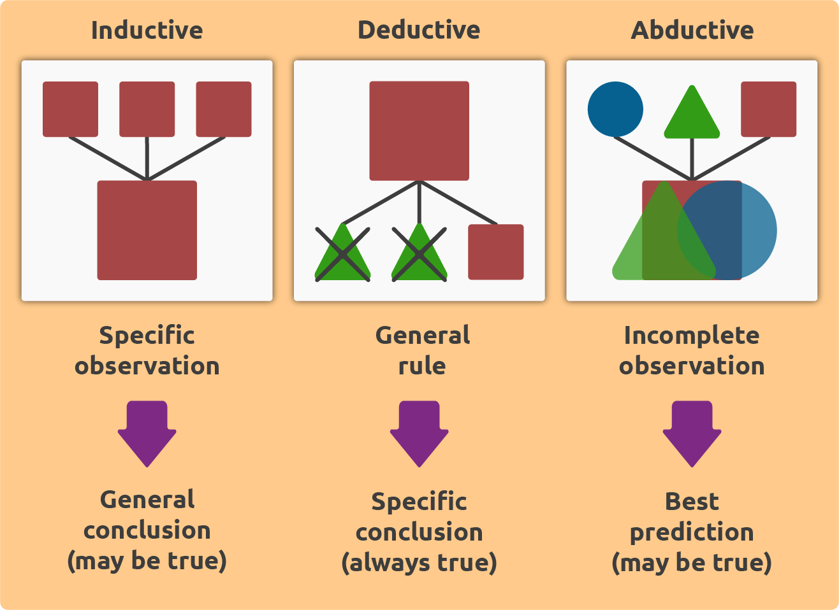

1. Learning

**Auditory Learning**

Kids learn a great deal from hearing.

Ex- someone is scolding us because of the high pitch in their voice and also understand the intent of the speaker because of a common language.

Machine Auditory Learning - A robot needs to convert sound signals into a machine-readable format.

Post-conversion the speaker and the recipient are on the same page and now the real learning process for a system begins.

Identify whose command has it received if there is such a necessity to know.

Understand the course of actions to be completed.

ALEXA from Amazon works on the voice input from a user. Which form of learning is involved here?

ALEXA and other similar talking devices use Auditory Learning. These systems divide the speech of a person into buckets like Wake Up, Utterances and Intent. “Alexa, can you help me with today’s weather”

**Episodic Learning**

We tend to remember certain set of events in order to reach a particular goal.

Example - going out of the house requires you to wear a set of footwear. In here required to wear socks first and then the shoes.

This whole learning process is episodic in nature, like a linear formula.

Robots need to remember these set of events as well.

Certain episodes can be either preprogrammed or it can be explored as per the input received from a human.

A human can guide it by providing a positive feedback for every desired action completed in order. A misalignment of actions will result in a negative feedback. (Ex- Forgot the vehicle key in side the vehicle and locked the vehicle. So human get negative feedback)

When the robot receives a negative feedback, it makes a note of the actions taken place till now.

It then understands that something is wrong, and maybe it should change its set of actions.

While building on the episodic learning, help the ALEXA robot by arranging the following action’s sequence:

1. Wake up and record the audio command
2. Divide the speech in buckets of Utterances and Intent
3. Analyse the Intent
4. Hit the search engine for weather update
5. Speak out the weather update

**Motor Learning**

Simple Example - Hand (there is one major motor movement for human)

To replicate the same in a robot is quite difficult.

Therefore only a limited number of actions are possible with them.

Those actions are further limited by the shape of object it can work with.

**Observational Learning or Imitation**

Ex- Kids Posing For photo because they imitation really well.

But for a robot to play the imitation game, it’s a different

This type of learning requires the robot to have a clear view of what its teacher is doing.

It needs to differentiate between the actions being performed by a human.

Like, a circular object is just rolled by the hand but a square object is lifted.

The robot should also differentiate between a circular and square object.

**Perceptual Learning**

Developing a perception requires number of senses to come together like seeing, hearing or touching.

Example- if kid touch hot kettle burn his hand. now understands the consequences of coming in contact with a hot object.

that mean developed a perception about hot objects and would preferably try to avoid it.

Like this Robot need lot of guidelines from human, Like staying away from fire.

* Perception is based on the absolute properties.

Example - Changes in shape, size and color of an object lead to the creation of Perception about it.

**Relational Learning**

This is about learning from Final outcome. Ex- If You made cake and It is pretty bad. Now You know that is the reason of leak of the material. So learn from output.

Relational Learning is different than Perceptual. It involves more of relational properties rather than absolute ones like shape, size or color. If perceptions are wrong, it will hamper the procedure of reaching the final goal.

Example - A bowler uses Trial-and-Error method to fine-tune his bowling action for a desirable result. What type of learning is being used over here. (With each delivery he must be changing his style or timing and hence it is relational in nature.)

**Stimulus-Response Learning**

This type of learning focuses on showcasing a particular behavior when some event occurs.

example - kid sees a guest wearing his shoes, he or she might run to get their own shoes thinking that it’s time to go out. Or when we hear a doorbell, we know that there is a need to answer the door.

1. Guidance v/s Exploration

All of the techniques we have seen in the previous topic can be accomplished by two main modes.

1. **Guidance**

A helping hand is provided by a teacher at every instant

This gets the task done much faster as there is hardly any trial-and-error involved.

1. **Exploration**

exploration, the human involvement is very less.

robot achieves its task by self-learning and thus more trial-and-error involved.

In an Exploration-based system, a robot is required to sort boxes on the basis of color. It learns on itself by noting whether the final state is desired or not(If the system is exploration-based, self-learning will be involved.)

1. Decision-Making

**Decision**, in simplest terms, exists when there is more than one option present. Machine’s decision-making capabilities are strong as well as weak. A simple If-Else is something what a machine is all about.

*If the ball hits the surface;*

*Make the ball bounce.*

*Else;*

*Keep the ball rolling in its trajectory.*

Decisions in machines are taken up on the basis of data.

The early form of AI used a Symbolic Approach. This approach required a large reference data to be available first hand. The machine will consult this data only and thus will respond accordingly.

Note –

Symbolic AI algorithms work by processing symbols, which represent objects or concepts in the world, and their relationships. The main approach in Symbolic AI is to use logic-based programming, where rules and axioms are used to make inferences and deductions.

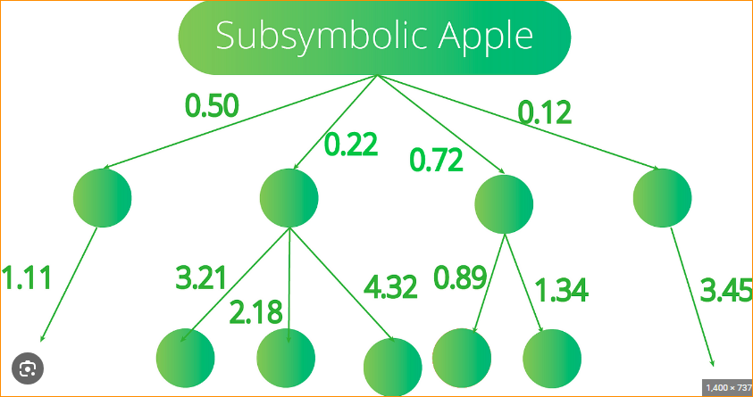

Example-

* Take an example of a QnA Robot (Question and Answer).To add to the complexity of this example, let’s say it deals only in Japanese.

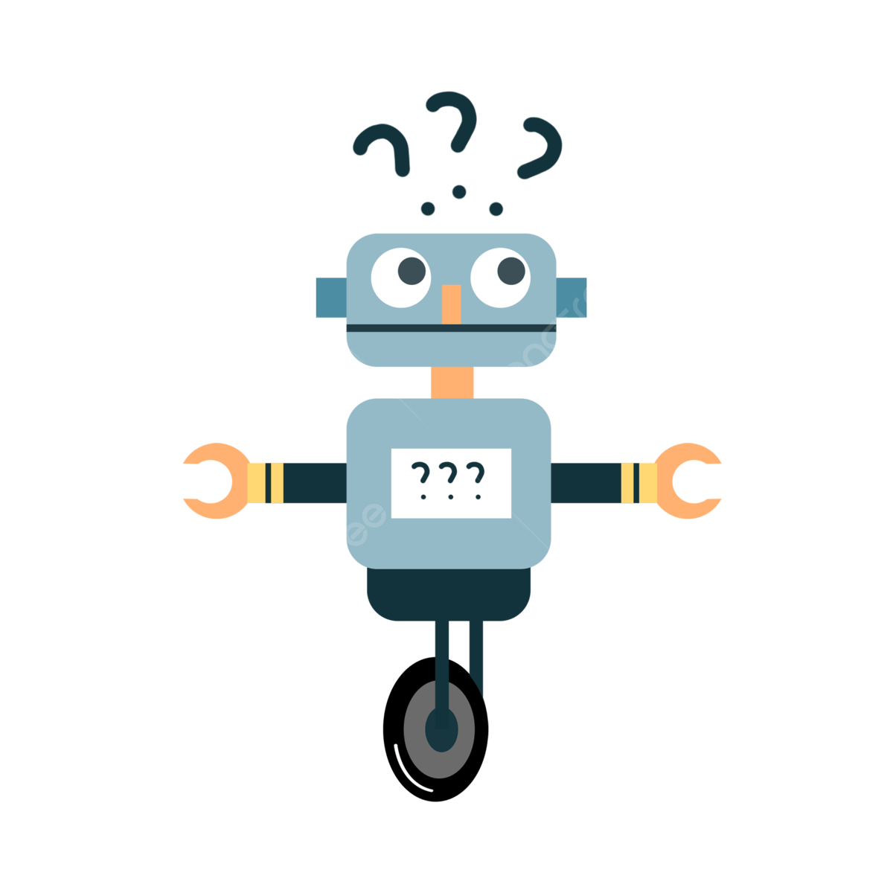

Obviously, in the beginning we need to provide a sufficient data set.

* So if someone says, “Sayonara” (Goodbye).
* The Robot should respond back something like “Ja Mata” (See you again).
* The symbolic approach works here, as every greeting will have a corresponding response.
* But what if someone says, “Mata ne” (See you soon), and our data set doesn’t have a response for it.
* Our system will go for a toss in that case.
* The symbolic approach has huge flaw. It is called as **Combinatorial Explosion.**

**The data set will keep growing with combinations every time something new comes up. This in turn will add up on the machine-time taken to find the right combination. Much of the Early AI was deemed limited because of this issue. So the researchers came up with an early form of human brain-like model.**

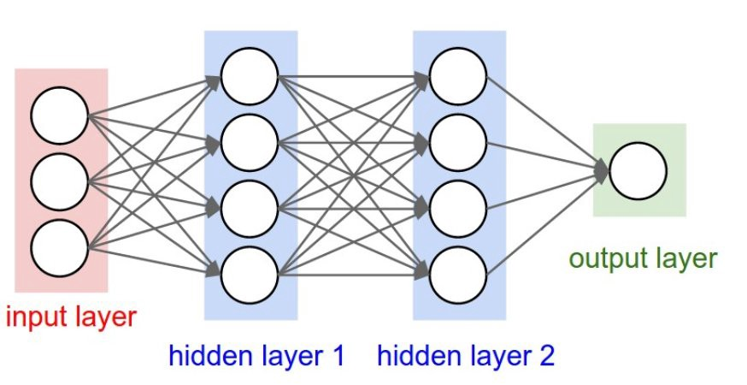

This model is more famously known as Neural Networks. In simple terms, this model consists of an input layer, output layer and a number of hidden layers in between.It is in the hidden layer, through a number of algorithms, the model decides on a confidence level over any input.

* Considering the QnA Robot, the hidden layers decide whether “Sayonara” and “Mata ne” belong to a common bucket of goodbye greetings.
* Once a greater confidence is established after searching through common patterns, the robot can then use its usual goodbye-based greeting.

1. Prediction and Judgement

Machines are good with calculations. They are even better than humans when it comes to complex calculations. Because of this, a machine is able to do Predictions.

Example - Let’s say, if we have all the past data available, a machine can predict number of road accidents that will happen in a region on a particular day.

Let’s say, the same machine is asked to exercise a control over this region to minimize number of road accidents. It will only look at the data and make decisions accordingly.The decisions made by machines can miss its consequences.

It might start with following enactments:

* Number of motorists on the road is too high; Increase the legal age to drive.
* Number of vehicles on the road is too high; Put a limit on automobile manufacturing companies.
* High amount of accidents happened because of Map Navigation on Smartphones; Ban it.

The data collected and the reasons it found are correct and sensible. but decisions taken by this machine are valid enough?

1. Human Limitations

The job of prediction can be done by a human brain as well.

we do predict innumerable scenarios in our head. But the data used by us is quite small in nature. This is where machines are introduced. Our human brain cannot handle tons of transactions. human memory-holding capacity is significantly smaller than a machine’s.

But Human beings are much more adept at judgements than the machines.

* Taking our road accidents example, we know that the machine’s decisions are not in the best interests of all the parties.
* Increasing the age limit will give rise to more unlawful driving; a correct number can be defined only by judgement.
* Similarly, method of using Map Navigation applications while driving needs to be changed rather than banned.
* Judging requires a bird’s eye view has to be taken of the complete scenario but prediction can just hit with right numbers.

Review=

* A bank is worried about the strength of its fraud-detection algorithm. This problem is related to?

The bank doesn’t want to hold a legitimate transaction as invalid just because of the strength of the algorithm. While at the same time, an illegitimate transaction shouldn’t be considered as valid because of the weak algorithm. Hence there is a trade-off.

* Symbolic approach provides much scalability and manageable data. Right or Wrong?

This approach tends toward more data to be made available for better results. Therefore it is difficult to scale.

1. Strong AI and Weak AI

John Searle differentiated between AI Systems based on their applicability in real world. This produced terms such as Strong AI and Weak AI.

**Strong AI** is also known as General Artificial Intelligence. It is basically a full-fledged human being created artificially. In Strong AI, a machine can showcase all the aspects of a human being. No matter how lucrative a Strong AI might look but its reality is still questionable.

Note- Strong AI (Artificial General Intelligence - AGI):

* Strong AI refers to a type of artificial intelligence that possesses the ability to understand, learn, and apply knowledge across a wide range of tasks at a level comparable to human intelligence.
* AGI would have the capacity to perform any intellectual task that a human being can do. It implies a form of consciousness and general cognitive abilities.
* Achieving Strong AI is a long-term goal and, as of my last knowledge update in January 2022, has not yet been realized. Most of the AI systems we encounter today are considered Weak AI.

**Weak AI**

Limited Scope - It is very limited in its scope and will work only on a specific task. It is also known as Narrow AI.

Think of Weak AI as a program intended to convert speech to text. Or just a program to schedule all your appointments. It will deliver only a specific task. Our AI systems as of now are a collection of few Weak AI Programs.

Examples - A talking assistant like Apple’s SIRI or Google Now are examples of Weak AI. But Weak AI have a lot of powerful features. These programs are still able to look into a lot of your records and provide a personalized result.

This kind of AI provides a more humane touch. Looking from a broader view, this kind of work can be done by non-AI systems as well.

Even a search engine can provide answers to your queries. But AI changes the mode of input and output to get in more personal details.

Note- Weak AI (Narrow AI or Artificial Narrow Intelligence - ANI):

* Weak AI refers to artificial intelligence systems that are designed and trained for a particular task.
* These systems are specialized and excel in a specific domain but lack the broad cognitive abilities associated with human intelligence.
* Most of the AI applications we encounter today, such as virtual assistants, image recognition systems, and recommendation algorithms, fall into the category of Weak AI.

1. Planning AI

that the early AI used Symbolic Approach. Even with its flaws, this approach is widely used today. Of course, some tweak has been made in this approach. To recollect, this approach had an issue of huge lists to search through before reaching the output. It is important to make the machine respond quickly and avoid searching through long lists. Therefore, we try to limit its search.( make an informed guess about the start and stop point of the search.) This method is called a **Heuristic Search**.

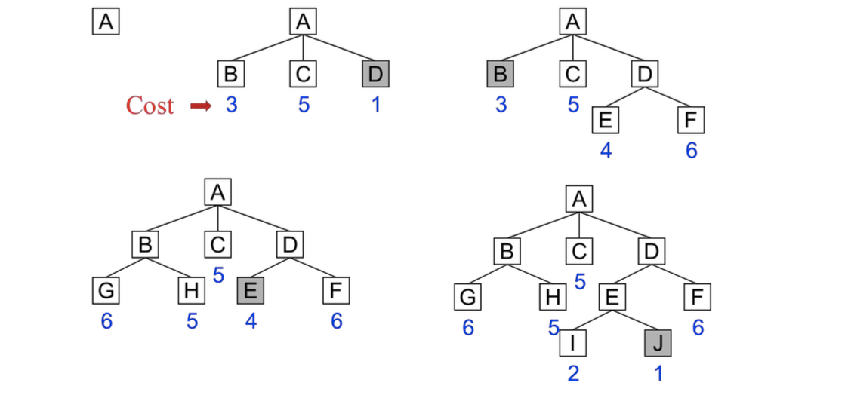

Example -

Restaurant Finder applications uses Heuristic Search.They try to either get your location or consider the time of the day to provide output. So a particular location will have a finite number of listed places open at that particular time.This limits the algorithm’s search.

Questions-

1. robot showcases keen interest in Sports on its own. What kind of an AI is this?

this is Strong AI It is like a human behavior.

1. A Language Translation application looks at wh-type questions first. This is an example of?

Heuristic Search , By doing this, it is limiting its search complexity.

1. Putting an alarm on your smartphone manually can be thought of as Weak AI. State True or False.? False.

Weak AI not just deals in a specific task but also looks into making it more humane in nature. A voice-controlled alarm will be a better choice for Weak AI.

1. Understanding Agents and Environments in AI

Agent

* In a similar way, **agents** of an AI system are like people around in real world.
* People, all are living our own life but we still work together and they work in groups as well as individually.
* Agents in AI can be thought of all the systems in a particular environment.

an agent in AI can be **Robotic Agent** or **Software Agent**. An agent is a machine that can feel its environment using various sensors.

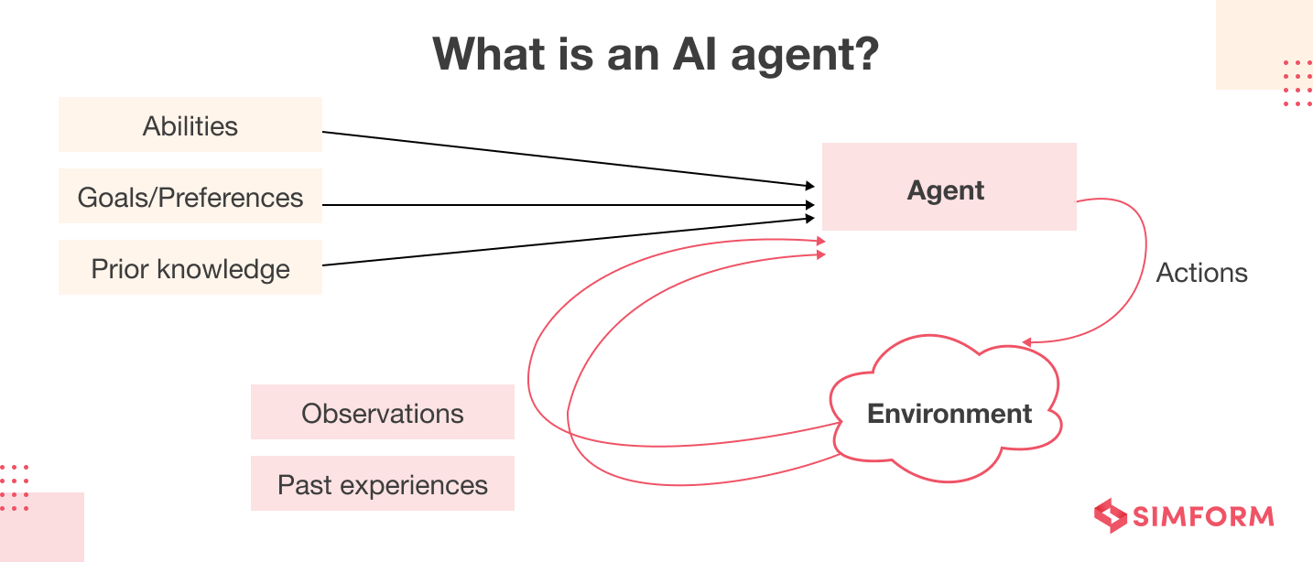

* Just like a human being, an agent in AI can be **Robotic Agent or Software Agent**. An agent is a machine that can feel its environment using various **sensors**. It can also act upon its environment through **effectors**.
* A robotic agent is built upon many software agents clubbed together.

**Robotic Agent**

* A human uses sensory organs like nose, ear, eyes, skin and tongue to perceive its environment.
* Similarly, a robotic agent have tons of sensors like camera, touch sensor, gesture-detection/ Human beings can use their hands, legs, mouth as effectors. Robotic agent uses different types of motors and actuators which help it in traversing.

**Software Agent**

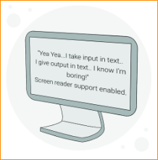

A software agent is quite simple in terms of understanding.

It has only bits of strings to make sense of its environment as well as act on it.

The complexity of these encoded strings keep varying but more or less that’s all they got.

A robotic agent is built upon many software agents clubbed together. But a software agent can exist as a standalone agent as well.

NOTE- “Intelligent software agents are defined as being a software program that can perform specific tasks for a user and possessing a degree of intelligence that permits it to performs parts of its tasks autonomously and to interact with its environment in a useful manner.”

In the context of artificial intelligence (AI), a software agent refers to a program or system that is designed to perform tasks or make decisions on behalf of a user or another program. These agents are autonomous entities that can perceive their environment, reason about it, and take actions to achieve specified goals. Here are some key characteristics and types of software agents in AI:

The degree of success for an **agent** is determined by its actions.

A **rational agent** is one whose actions are the ones desired by all. In other words, every action performed must be reasonable and should be valuable.

**Ideal Rational Agent**

An ideal rational agent is the one who maximizes its performance on the basis of:

* What knowledge it has acquired about its environment
* What knowledge it already had about its environment

An agent can be thought of any basic technology item or maybe even a sundry item.

It can be as simple as a thermometer to as complex as a self-driving car.

Example-

We will take an example of a Traffic Signal.

* Red - Stop
* Amber - Warning to Slow down
* Green – Go

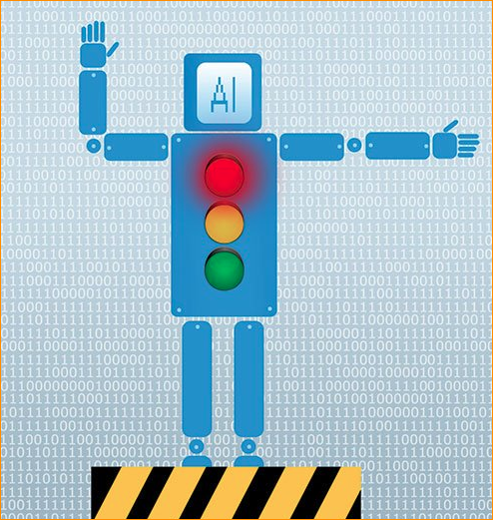

Rational behavior

* A rational approach for Traffy would be to **provide reasonable timeframes** for all 3 lights on it.
* It shouldn’t be like Red is on for 120 seconds but Green is for just 5 seconds. Also, Amber’s time shouldn’t be too much like 10 seconds.

An intelligent agent’s structure can be viewed as:

**Agent = machinery it can control + how it exercises control on its machinery**

**(body) (mind)**

Note-

It looks like you're attempting to define or describe the relationship between an intelligent AI, an agent, and the machinery it controls, considering both the physical (body) and cognitive (mind) aspects. Let's break down the components:

**Intelligent AI:**

artificial intelligence system that possesses the ability to understand, learn, and apply knowledge in a manner similar to human intelligence. It may involve problem-solving, learning from experience, and adapting to different situations.

**Agent:**

An agent, in the context of AI, is a software entity or system that acts autonomously to achieve specific goals. It can perceive its environment, reason about it, and take actions to achieve its objectives.

**Machinery it can Control (Body):**

This refers to the physical components or devices that the AI agent has the capability to control. In a robotic context, this could be motors, actuators, sensors, or other physical mechanisms that allow the AI to interact with and manipulate the environment.

**How it Exercises Control on its Machinery (Mind):**

This represents the cognitive or decision-making aspect of the AI agent. It involves how the agent processes information, analyzes the environment, and determines the appropriate actions to achieve its goals. This could include decision-making algorithms, planning mechanisms, and learning processes.

In summary, the intelligent AI is conceptualized as an agent that has both a physical aspect (machinery it can control or body) and a cognitive aspect (how it exercises control on its machinery or mind). The body refers to the physical components the AI can manipulate, and the mind refers to the cognitive processes governing how it makes decisions and controls its actions.

This conceptualization aligns with the idea that intelligent AI systems often involve a combination of hardware (physical components) and software (algorithms and decision-making processes). The synergy between the body and mind allows the AI to interact with its environment in an intelligent and adaptive manner.

Depending on this structure, we can get different types of behavior from Traffic control.

A simple reflex agent works on a single condition and takes a corresponding action. Here, the agent doesn’t have any prior knowledge about the environment. They just sense the environment and based on their decision-mapping take the course of action to be completed.

Traffic light in its usual avatar works as a simple reflex agent. At any point, it just counts the time for which a light will remain on. Once that is completed, it moves to turn on another light. And so this keeps going on.

A model-based reflex agent tries to know the current state of the environment. Depending on this state it can tweak its regular corresponding actions. Model refers to how things actually happen in a real world scenario.

* What is a Model-Based Reflex Agent?

A model-based reflex agent is one that uses internal memory and a percept history to create a model of the environment in which it's operating and make decisions based on that model. The term percept means something that has been observed or detected by the agent.

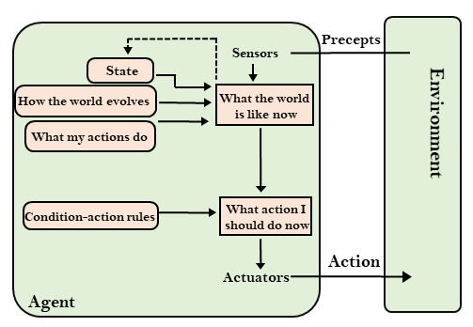

* Traffic light system as Model-based Reflex Agent

Traffic light system gets a camera as a sensor which helps in detecting Traffic Density. If this density is huge, Traffic light system will keep its Green Light on for more duration. Else Green Light remains on for its normal duration. Traffic light system can also tweak its system depending on the time of the day. So usually at night, the traffic density will be low and therefore it act accordingly.

**Goal-based Agent**

* A goal-based agent works towards a goal rather than just changing its output on the basis of environment state. It looks at a bigger picture rather than just doing tasks in small portion. A goal is a desirous situation which we want our agent to reach.

Traffic System as Goal-based Agent

* Traffic System was just looking at a single lane. but now works at a very busy 4-way street of the city. Now it has to work along with 3 other traffic signals.
* The goal of this entire system is efficient traffic management on all 4 sides of the street.
* If the traffic density is high on Traffic System’s side, it just can’t keep its Green Light on for more time duration. It is not a single agent world any more. It turns into a multi-agent environment. Therefore it will require more effectors/sensors to communicate with each other.
* Sometimes goals can be insufficient when there are conflicting goals and only few can be achieved

**Utility-based Agent**

Sometimes goals can be insufficient when there are conflicting goals and only few can be achieved. also need to know the importance of a particular goal against the performance of the whole system. Utility-based agent tries to alter their goals over a preference.

For Traffic Light and its colleagues, the objective is to smoothen traffic congestion.

But there is one aspect missing from their objective.

They should be able to handle uncertain events as well.

An ambulance is either stuck in traffic congestion or halted at a less density side. The aim should be to always provide clear passage for an ambulance to move forward. This will require detection of ambulance which can be handled via Image Processing techniques.

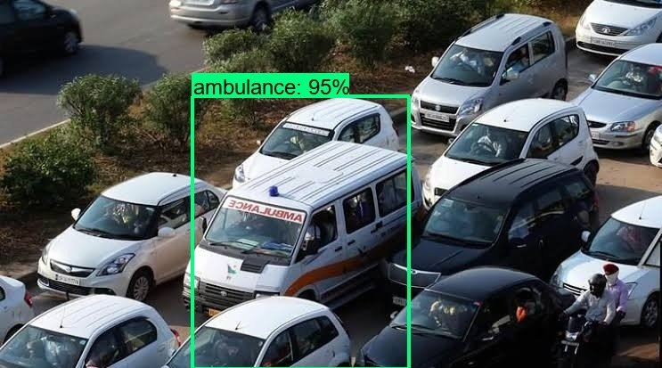

Utility can be thought of happiness experienced by an agent after performing an action.

**PEAS**

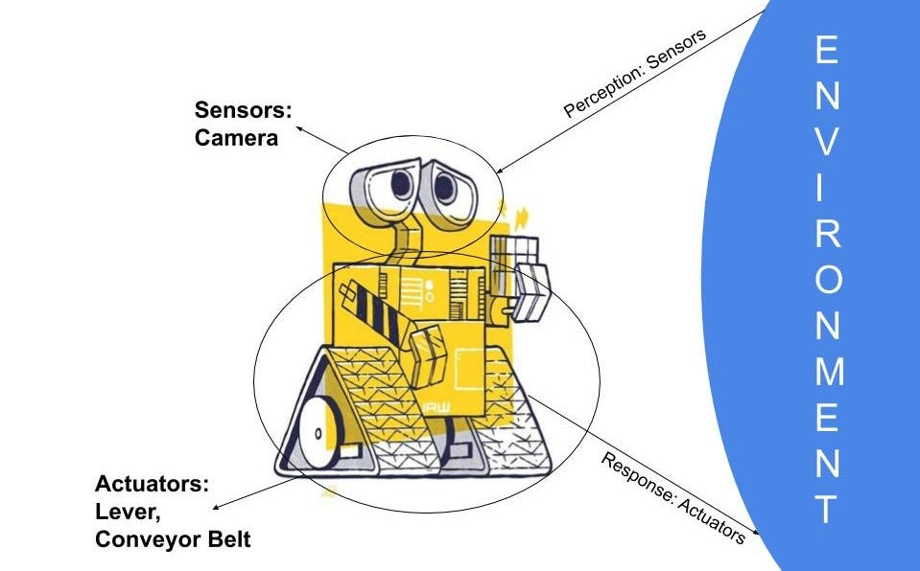

* Any problem that an agent tries to solve is based on this acronym called PEAS.

P - Performance Measures like how efficient is the system, is it available all the time or does it require lot of maintenance.

E - What sense has our agent made of the Environment.

A - Actuators or Motors to act upon the environment.

S - Sensors used to perceive the environment.

* The problem for Traffic light

P - Efficient, Utilitarian, Availability, Traffic Density, Number of vehicles moved per minute

E - Different vehicles, Birds as obstacles, Extreme sunlight

A - Traffic Lights

S - Camera, Image Processing

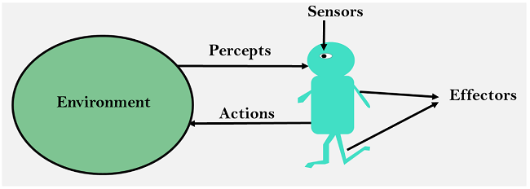

PEAS other examples-

1. Autonomous taxi

Performance measure - Safe, Fast, Legal, Comfortable trip, Maximize profits

Environment – Roads, other traffic, pedestrians, customers

Actuators – Steering wheel, accelerator, break, signal, horn

Sensors – Cameras, LIDAR, Speedometer, GPS, Odometer, engine sensors, keyboard

1. Spam Filter

Performance measure - Minimizing false positives, false negatives

Environment – A user email account, email server

Actuators – Mark as spam, delete

Sensors – incoming messages, other information’s about user’s account

1. Medical diagnosis system

Performance measure – Healthy patients, minimize cost, fewer lawsuits

Environment – Patient, hospital, staff

Actuators – Screen Display(questions, tests, diagnoses, treatment, referrals)

Sensors – Keyboard (entry of symptoms, finding, patients answers)

Agents Summary –

**Agent**:

An agent is an autonomous entity that perceives its environment, processes information, and takes actions to achieve specific goals or objectives.

Agents can be software programs, robots, or any system capable of interacting with its surroundings.

Characteristics of an agent include autonomy, reactivity (responding to changes in the environment), proactiveness (taking initiative), and the ability to learn and adapt.

**Types**

* Simple Reflex Agents:

These agents select actions based solely on the current percept (sensory input) without considering the history of events.

They are reactive and do not have the ability to maintain an internal state.

* Model-Based Reflex Agents:

Model-based reflex agents, in addition to reacting to the current percept, maintain an internal model or representation of the world.

This internal model allows the agent to consider the history of events and make more informed decisions.

* Goal-Based Agents:

Goal-based agents operate by considering their goals and taking actions that move them closer to achieving those goals.

They can reason about the desirability of different states and plan actions accordingly.

* Utility-Based Agents:

Utility-based agents make decisions by evaluating the utility or desirability of different outcomes.

They consider the overall value or satisfaction associated with different states and choose actions that maximize utility.

* Learning Agents:

Learning agents have the ability to adapt and improve their performance over time based on experience.

They can learn from the consequences of their actions and adjust their behavior accordingly.

* Rational Agents:

Rational agents are those that take actions that maximize their expected performance measure given the information available to them.

They make decisions that are logically sound and aligned with their goals.

* Adversarial Agents:

Adversarial agents are designed to operate in competitive environments where other agents may have conflicting goals.

Examples include agents in game-playing scenarios where each agent aims to outperform the others.

* Reactive vs. Deliberative Agents:

Reactive agents respond quickly to environmental changes without much planning.

Deliberative agents, on the other hand, engage in more thoughtful planning and decision-making.

* Hybrid Agents:

Hybrid agents combine characteristics of different types of agents. For example, a hybrid agent might be both goal-based and reactive.

* Intelligent Agents:

Intelligent agents possess advanced cognitive abilities, including learning, reasoning, problem-solving, and adaptation to changing environments.

These agents may incorporate elements of various agent types to achieve a high level of autonomy and intelligence.

These categories provide a framework for understanding the diversity of agents in AI systems. Depending on the specific task, environment, and requirements, different types of agents may be employed to achieve optimal performance.

QAS –

1. A particular self-driving car works only on “If no obstacle in sight, keep going forward” logic. This agent falls in which of the following category

Simple Reflex agent

the agent is taking action on the basis of only one condition.

1. A map navigation software provides you the results on the basis of shortest time v/s shortest distance. This agent falls in which of the following category Select the right answer

Utility base agent

The agent’s goal over here is to provide a route from source to destination. Taking in time factor can make it considered as a preference.

1. “Press 1 for English. Press 2 for Hindi”. Choose the best option possible.

Here we are asking user to input something and therefore it can be considered as a Sensor part from the acronym PEAS

1. Environment

about Environment within which an Agent operates. that an Environment is the space where an AI Solution operates in.

Every such environment exhibits different characteristics. These characteristics make the agents work on their PEAS aspect.

**Fully Observable vs. Partially Observable**

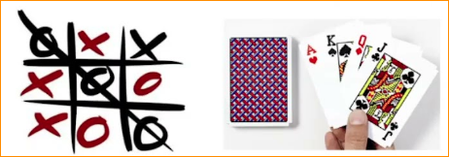

* An environment can be Fully Observable vs Partially Observable.
* A fully observable environment is where at any given state the agent have all the information to complete its action. Chess is a classic example of such an environment.
* The game is completely open to both opponents unlike Card Games where only a part of your game is opened.

Fully Observable: In a fully observable environment, the agent's sensors provide complete and accurate information about the state of the environment at any given time.

Partially Observable: In a partially observable environment, the agent's sensors provide incomplete or uncertain information about the environment, requiring the agent to maintain internal beliefs or models.

**Competitive vs. Collaborative**

A game environment like Chess or Scrabble is competitive in nature. Each agent wants to maximize their performance.

but an example of Traffic light system was a collaborative one. All 4 signals out there were trying to work towards a common goal.

**Static vs. Dynamic**

Static: In a static environment, the elements and their properties do not change over time.

Dynamic: In a dynamic environment, the elements, properties, or relationships change over time.

* Static environments have data sources that do not change over time. The environment’s state remains unchanged. A software agent working on past 10 years population data will be categorized as static.
* Traffic light system environment was dynamic as vehicles appeared small and large numbers.

**Discrete vs. Continuous**

* Whenever an environment can produce only fixed set of outcomes, it is termed as discrete.

Chess again will be termed as discrete as every piece can exhibit a set outcome only.

* Continuous is where the state of an environment can assume many different forms.

A drone flying high can capture different vision at any given point of time.

Discrete: In a discrete environment, there is a distinct and countable set of states, actions, or outcomes.

Continuous: In a continuous environment, states, actions, or outcomes are not limited to a discrete set and may have a continuous range.

**Deterministic vs. Stochastic**

* A deterministic environment is where on the basis of the specific state, we can derive an outcome.

Traffic light system can be considered as partially deterministic whereas Chess is fully deterministic.

* Most of the real-world AI problems are stochastic in nature like a self-driving car.

Deterministic: In a deterministic environment, the outcome of an action is entirely predictable and follows fixed rules.

Stochastic: In a stochastic environment, there is some degree of randomness or uncertainty in the outcomes of actions, even if the agent's actions are the same.

**Episodic vs. Sequential:**

Episodic: In an episodic environment, the agent's experience is divided into separate episodes or tasks, and the outcome of each episode is independent of the others.

Sequential: In a sequential environment, the agent's actions and outcomes are part of a continuous sequence, and the current action affects future states.

**Known vs. Unknown:**

Known: In a known environment, the agent has complete knowledge of the environment's dynamics, rules, and possible states.

Unknown: In an unknown environment, the agent lacks complete information about the environment and must explore and learn over time.

**Single-Agent vs. Multi-Agent:**

Single-Agent: In a single-agent environment, there is only one agent interacting with the environment.

Multi-Agent: In a multi-agent environment, multiple agents operate concurrently, and their actions may affect each other.

**Accessible vs. Inaccessible:**

Accessible: In an accessible environment, the agent can access all relevant information about the environment.

Inaccessible: In an inaccessible environment, certain information may be hidden or unavailable to the agent.

The next state of the environment cannot be determined as there are lot of random variables in picture.

Agents and environments define the world of an AI system.

The different characteristics of an environment make the agent’s rationality change. This in turn changes their Performance measure and therefore it is important to consider environment as well when designing an AI system.

QAS

1. A software agent is analysing the voice message of a political leader to highlight his/her party’s agenda. Its environment can be termed as Dynamic in nature. State True or False.

False.

voice message is not going to change with time. Whatever topics he/she has talked about are captured. So the input source remains constant.

1. A self-driving car operates in a ______ environment.

Collaborative & Partially Observable

It cannot go in a competitive mode with other vehicles after all it’s not a race.

1. Research fields

AI is seen as a field of **Computer Science.**

But in reality, there are many fields which have contributed toward its development. AI can be seen as an amalgamation of various fields. If we are making a process intelligent, it is important to know the domain in which it is working.

Therefore most of the fields have played an important role in boosting AI as a field, like:

* Computer Science
* Maths
* Statistics
* Biology
* Philosophy

**Predictions** and **Patterns** along with **Decision-Making** play an important role in AI.

Each field has its own rule-set and therefore work begins from scratch with focus on AI. There are experts of each field, maybe even music, to help compile huge lists of conditions and rules.

1. Machine Learning and Symbolic Approach

Few key concepts:

* Symbolic Approach
* Machine Learning using Artificial Neural Networks (ANN)

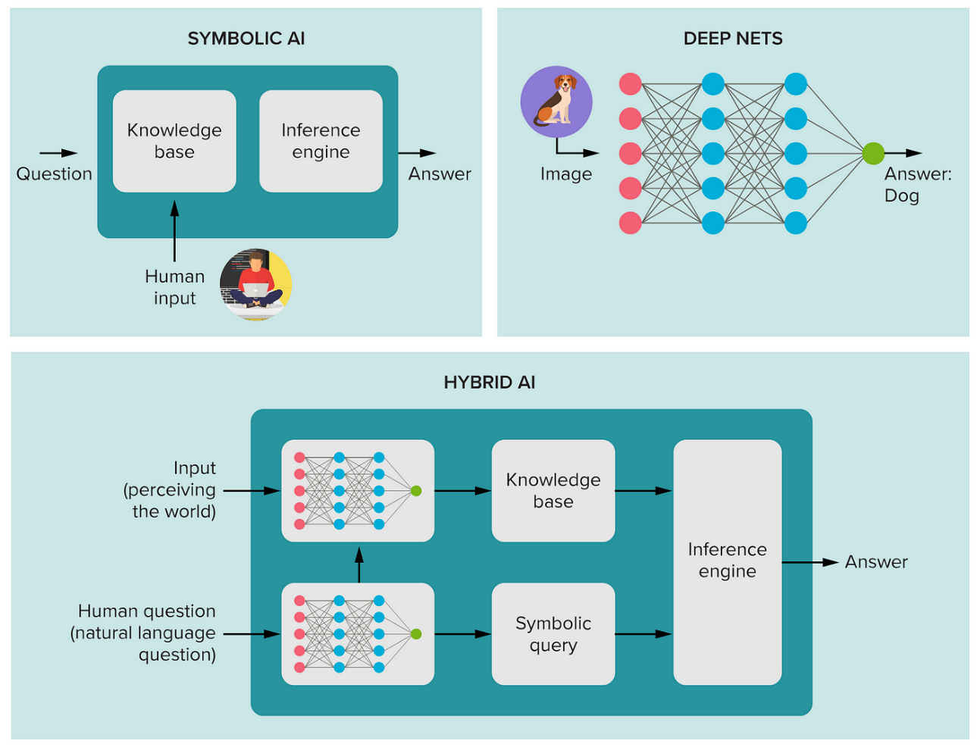

**Symbolic Approach**

* Symbolic Approach is where every possible condition of a problem is noted down.
* These can be really long lists and will require a domain expert to create it.

Note-

The symbolic approach to artificial intelligence (AI) is a paradigm that focuses on the manipulation and processing of symbols and symbolic representations to mimic human cognitive processes. This approach contrasts with connectionist or sub-symbolic approaches, such as neural networks, which rely on the parallel processing of simple, interconnected units.

1. Symbolic Approach:

Representation: Symbolic AI relies on explicit representation of knowledge using symbols, rules, and logic. Knowledge is often structured in a way that is interpretable and understandable by humans.

Inference: Reasoning and inference in symbolic AI are typically rule-based and involve the manipulation of symbols. Deductive, inductive, and abductive reasoning are common methods used for drawing conclusions.

Knowledge Acquisition: Human experts often play a crucial role in encoding knowledge into the system. Knowledge acquisition involves capturing expertise in the form of rules, facts, and relationships.

Transparency: Symbolic systems are often transparent, meaning that the reasoning process and decision-making can be traced and understood by humans.

1. Artificial Neural Networks (ANNs):

Representation: ANNs, on the other hand, use a distributed representation of knowledge in the form of interconnected nodes (neurons) and weights. The strength of connections between neurons is adjusted during training based on data.

Inference: ANNs perform parallel processing and can learn complex patterns and relationships from data. They are particularly well-suited for tasks such as pattern recognition, classification, and regression.

Knowledge Acquisition: ANNs learn from data through training processes, adjusting weights to minimize errors in prediction. They do not rely on explicit rules provided by human experts.

Transparency: Neural networks, especially deep neural networks, are often considered as "black boxes" because understanding the exact reasoning behind a specific decision can be challenging.

1. Integration of Symbolic and Neural Approaches:

Hybrid Systems: There is ongoing research on combining symbolic reasoning with neural networks in hybrid systems. This involves integrating the strengths of both approaches to address their respective weaknesses.

Neuro-Symbolic Systems: Neuro-symbolic systems aim to bridge the gap between symbolic reasoning and neural networks. This involves using neural networks to learn representations from data and then integrating symbolic reasoning for higher-level cognitive tasks.

1. Example Integration Scenarios:

Commonsense Reasoning: Symbolic reasoning might be employed for tasks requiring commonsense reasoning, while neural networks are used for pattern recognition and learning from examples.

Explainability: Symbolic rules can be used to provide explanations for the decisions made by neural networks, enhancing the interpretability of complex models.

**Machine Learning with ANN**

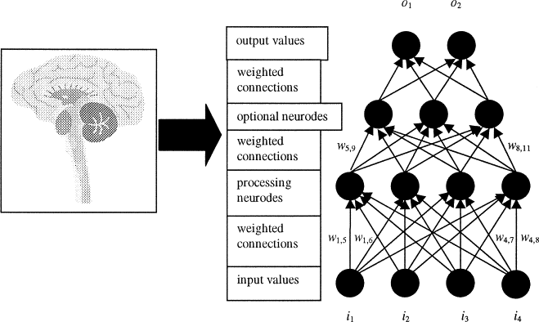

Machine Learning doesn’t keep an input list of conditions and actions.

Instead it is fed with all possible input and a Artificial Neural Networks(ANN) is used.

The ANN throws its own understanding as what patterns it can see.

How it sees this pattern, is a complete mystery.

ANNs can be **supervised or unsupervised**.

**Supervised vs Unsupervised**

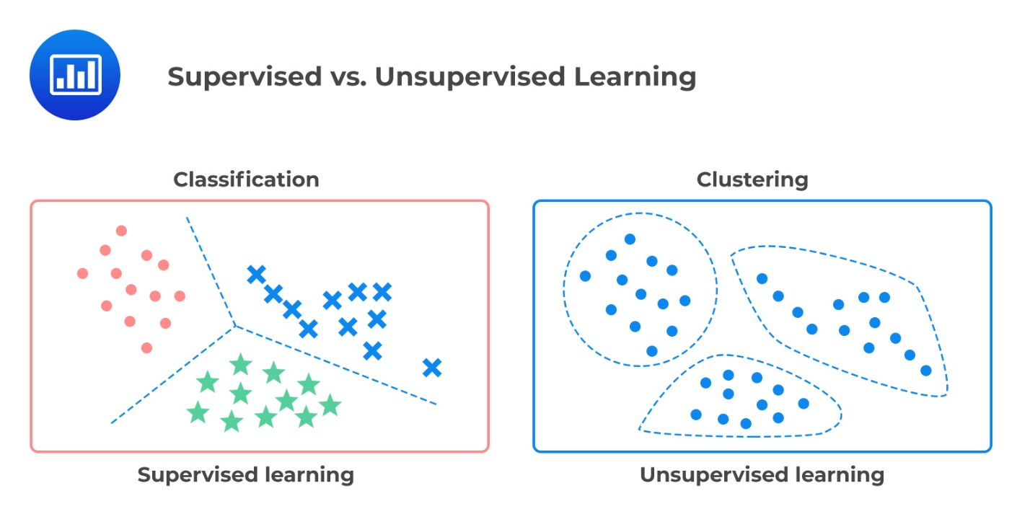

**Supervised ANN**

* In supervised, after each pattern is created, a human tries to correct it gradually.
* Tweaking in hidden layers of the ANN is performed.
* Slowly, Supervised ANN starts to generate the required output.

**Unsupervised ANN**

* In unsupervised, desired output is unknown.
* We are just letting the algorithm to go all bonkers and surprise us with its findings.
* such rare phenomenon, researchers try to reason it.
* this is call this as **Machine Conjuring**.

1. Related Technologies to AI

**Robotics**

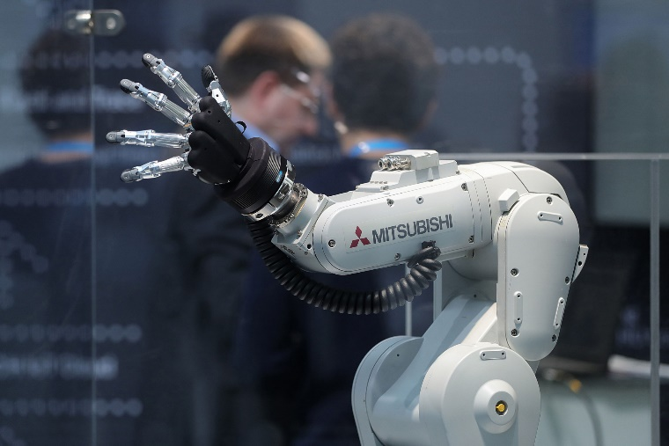

Robotic arms have been around ever since industrialization kicked in.

Huge machinery was built to aid the human productivity.

A lot of repetitive tasks were completed by Robots. Robotics let agents act in a physical world, sensing and acting like a human

AI in Robotics is required to let machines interact with more human touch.

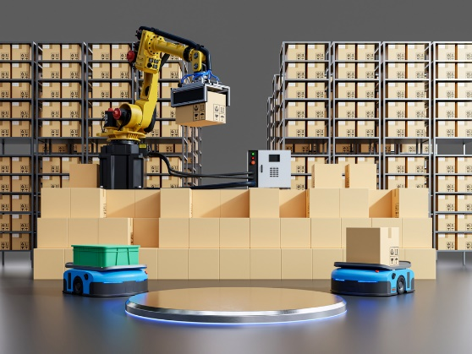

Type of AI to be used is pre-decided like Planned AI. A lot of consideration is placed on Environment. Think of a robot deployed in a warehouse to fetch various items from hundreds of racks. The robot in a warehouse will have an indoor environment condition. It’s job is to pick the correct package while avoiding any obstacle in its path. This agent should be created in a way that every section of each rack is reachable.

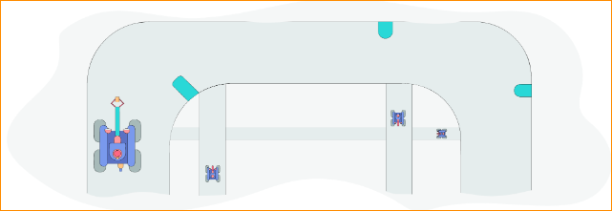

The conditions it has to cater to are limited.

Therefore, a Symbolic Approach along with **Heuristics** will work fine.

There are no pattern-finding or prediction involved and therefore Machine Learning is NOT a necessity.

A Self-Driving car is an example where **Supervised Machine Learning** will be required.

**Natural Language Processing (NLP)**

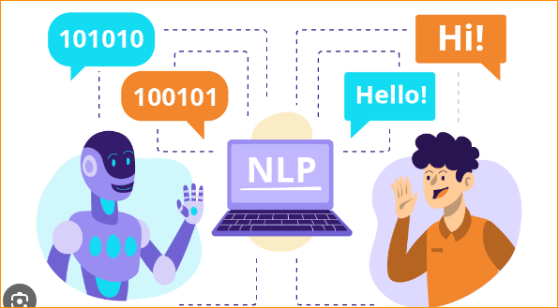

Machines are really good at communication with other machines. Everything is structured and there is no issue in the intent of the message. But human beings are bad with context and meaning of message. Each one has their own style, sarcasm, delivery of speech. Our form of speech is unstructured. In order for the machines to interact with us, it is important to understand what is the meaning behind our words. It needs to distinguish between our utterances and intent. (Think of **ALEXA**)

Intent can be either in active voice or passive voice. Both means the same command. For this, a symbolic approach will fail as we’ve seen in Japanese Translation of Greetings.

NLP uses unsupervised ANN which requires large input to find a pattern between our unstructured text. It is also important for the machine to understand the context.

Humans use a lot of relative words to express the actual subject.

A machine needs to understand a clear input to process the actions.

**Internet of Things (IoT)**

We are aware of many different sensors.

From heart-rate monitoring to presence of people in a room, we are surrounded by sensors.

There is a huge availability of sensors because of low cost and small size. IoT deals in collection of data from such small and tiny sensors around. After knowing a logical connection between such sensors, their data is used to perform some action.

An industrial application can be refilling of inventory on the basis of current stock.

Due to IoT based devices, a large amount of insights can be gathered.

Taking the inventory example ahead, let’s say a nation-wide retail chain can collect data from all its Inventory Sensors on Cooking Oil product.

With the timestamp data and corresponding stock levels, the retail chain can produce huge number of insights. It can understand the seasonal demand of products.

Products can be drilled down to its packaging variants as well.

Like:

During certain festivals, the Big Pack (5 litres) of a particular cooking oil was in higher demand.

**IoT can use both Supervised and Unsupervised ANNs**.

If the problem is known, like why sales dipped during month of May, a supervised method will suffice.

But if the company wants some new findings, like Small Pack of their Cooking Oil is used more on a Thursday, then an Unsupervised ANN can be used. It completely depends on the algorithm what kind of insight it will find.

QAS -

1. An application where changes in patterns lead to new clusters can be using _________ approach.

Machine Learning - ML takes in large set of inputs and then try to bring out various patterns. A slight change in pattern can create new categories.

1. Symbolic Approach requires an end-to-end understanding of all the scenarios of an application. - True ( A long list of condition-action needs to be created.Proceed)
2. A robo-based vacuum cleaner cleans the house and avoids furniture. It must be using which of the following approach? -

Symbolic

The furniture is more static problem along with not many variations. Therefore it can be completed via Symbolic Approach. A simple if-dirt; clean-it action can be used.

Issues with AI

1. Ethical Issues

Every new technology has its own share of problems. AI has been always debated over the topic of Human Jobs.

But there are a few more questions that need to be addressed other than the usual one. If not today, maybe some time in future, but this issue looms large. But all is not lost for human intelligence.

AI is capable of performing tasks which have some pattern related to it.

If a particular team is building an AI-based product, majority of the team strength is formed by IT background.

Some other field people are present to build the condition-action rules since they are the Subject-Matter Expert.

But there is hardly any space for people from either Cultural or Humanities background.

**Ethical Issues - AI Chatbot**

Recently, Microsoft launched its AI Chatbot on Internet.



The idea was to train it with the information poured on Twitter by common people.

Post this, it will use all the ideas received and will be able to chat or share its own thoughts.

The problem was that people poured in with lot of hate content. This volume became a bottleneck.

The chatbot started using hate language. The problem here is not of technology as it was functioning perfectly well in the space of Machine Learning.

This issue is more on the creativity side rather than technological. The chatbot was never introduced to philosophical studies or even basic manners.just like a parrot, it returned back with a volley of abusive words.

**Ethical Issues - Self-driving vehicles**

A much bigger issue lies with the judgment part of the machines.

We have progressed considerably in building self-driving cars.

A human life will always be at stake as people are a part of its environment.

Does the self-driving car algorithm knows about the emotional turmoil of getting involved in an accident.

But its major impact is going to be on human lives.

Therefore, it is of utmost importance for AI teams to accommodate experts from Humanities or any other related field to be a part of it right from the beginning.

**Technological Issues**

While artificial intelligence (AI) holds great promise, it also presents several technological challenges and issues that researchers and developers need to address. Some of the key technological issues related to AI include:

* **Lack of Data Quality:**

Issue: AI systems heavily rely on large datasets for training.

Challenge: Poor-quality or biased data can lead to inaccurate models and biased outcomes.

* **Data Privacy and Security:**

Issue: AI often involves the processing of sensitive and personal data.

Challenge: Ensuring the privacy and security of data is crucial, and mishandling data can lead to legal and ethical consequences.

* **Interpretability and Explainability:**

Issue: Many AI algorithms, especially deep learning models, operate as black boxes.

Challenge: Understanding and explaining the decision-making process of complex AI systems is essential for user trust and regulatory compliance.

* **Scalability:**

Issue: AI models may struggle to scale efficiently as data and computation requirements grow.

Challenge: Developing scalable AI systems that can handle increasing volumes of data and demand computational resources.

* **Computational Power Requirements:**

Issue: Training sophisticated AI models can demand substantial computational power.

Challenge: Addressing the environmental impact and energy consumption associated with training and running AI models.

* **Transfer Learning and Generalization:**

Issue: AI models may struggle to generalize well to new, unseen scenarios.

Challenge: Improving the ability of AI systems to transfer knowledge from one task to another and generalize across diverse datasets.

* **Robustness to Adversarial Attacks:**

Issue: AI models can be vulnerable to subtle manipulations of input data.

Challenge: Developing AI systems that are robust to adversarial attacks and ensuring the security of AI applications.

* **Real-Time Processing:**

Issue: Some AI applications require real-time processing, which can be challenging for complex models.

Challenge: Developing efficient algorithms and systems capable of real-time decision-making.

* **Human-AI Collaboration:**

Issue: AI systems may not seamlessly integrate with human workflows.

Challenge: Designing AI systems that enhance human productivity and collaboration rather than replacing human roles entirely.

* **Algorithmic Bias:**

Issue: Biases present in training data can result in biased AI models.

Challenge: Mitigating algorithmic bias and ensuring fairness in AI models by employing techniques like bias detection and correction.

* **Ethical Implementation:**

Issue: Ensuring that AI technologies are developed and deployed ethically.

Challenge: Establishing ethical guidelines, standards, and frameworks for AI development and use.

* **Continuous Learning:**

Issue: AI models may need to adapt to changing environments and data.

Challenge: Enabling AI systems to continuously learn and update their knowledge over time.

**Data Privacy Issues**

With NLP, machines are able to extract information and make sense of it.

It can chart out different categories of data as per importance of data contained in it.

This make machines capable of understanding the context of a confidential report.

A hacker can command the AI to create a summary of the confidential report and then it can be distributed.

**Decision-making Issues**

Along with this, AI has its own judgement-based issues.

In order for an unsupervised ANN, large sets of data is required.Sometimes providing this much information is also a challenge. The volume of input or training data skews the judgment of an AI system.

**High volume of data**

Our current era is known as an Information Age.High amount of data is being created in every second.The time required to analyze this much data before a new batch arrives is very huge.

This makes people compromise on the data set being provided for training.

**Summary**

* Issues with AI are more evident on social behavior side.
* It is hard to make a decision on the basis of quantitative data alone.
* Along with this, AI’s output is being processed by human beings directly.
* Ethical Issues in AI deals with Statistics only. State True or False.
* Select the right answer
* It is related to the human side of issues.

QAS

1. NLP’s capabilities are raising issues related to _________.

Privacy

It deals with understanding the confidential data and making it public.

1. Data Science & Big Data
2. **Lots of Data**

The advent of Internet was a boon for mankind.

With social media’s outbreak, more people experienced Internet.

This whole thing brought in huge influx of data. this is not the only factor behind the volumes of data created today. We are experiencing an era where data is created at lightning speed. But the problem comes in while analyzing this data. This gave rise to the problem/opportunity of Big Data. It is related to large amounts of data in absolutely every form possible.

Big Data as an application has helped drive AI algorithms.

Big Data helps in organizing large chunks of data.

Neural Network (NN) requires large data sets in order to make any sense of it.

Be it Supervised or Unsupervised; a lot of data is required at input layer. Because of this, the network is able to find unknown patterns. But again, what kind of pattern it throws, nobody knows.

1. **Data Mining**

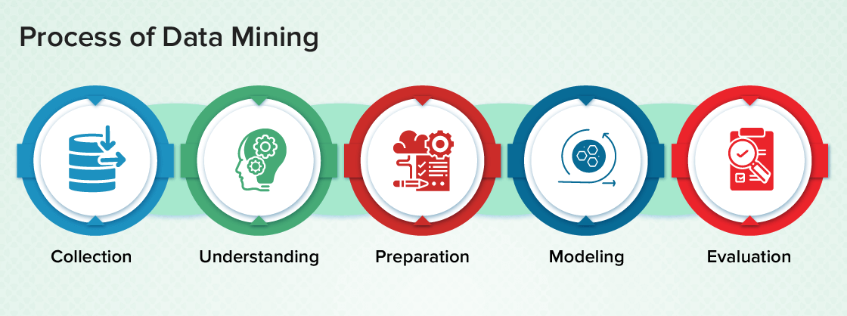

Big Data as a field has not just helped with ML.

A more basic form of reaching to insights out of a large dataset is known as Data Mining. You can even use an Excel Application to perform Data Mining. The questions or the patterns which are to be found are clearly defined in Data Mining. It is like finding a needle from a haystack. Another important application in finding insights is Data Science.

1. **Data Science**

Data Science have very specific questions and thus provides very specific answers. Neural Networks will tell about unknown patterns. To find why such a pattern exists is the task of Data Science. Data Science works more closely with data than Machine Learning. It gets to the depth of every possible scenario related to that data. Due to this, it knows more about the reasons behind the patterns. Whereas a Neural Network will only act on large datasets.

Example - So if number of accidents are huge at a given location, ML can come up with an insight as:

60% of all cars involved in the accident at that location were Toyota manufacturer vehicles.

Similarly, for this insight, Data Science can come up with following explanation:

The location has only one Car Dealer available within a radius of 10 kms. This dealer happens to be Ford.

Finding out such a reason seems to be the work of common sense. But imagine if your dataset runs into millions of rows.

1. AI along with other technologies
2. **Expert Systems**

Expert Systems have been the very first of AI applications.

It was based on GOFAI or Good Old Fashioned AI.

Machine Learning or Data Science are not always necessary.

Symbolic approach can be still used if it matches the requirements.

Expert Systems (ES) are used to solve a complex problem in a particular domain only.

With the help of a professional expert, a Knowledge Base is created.

Over this, the ES applies its inference engine and provides output.

This makes the use of Reasoning in machines to a greater extent.

It looks like as if machine is doing some complex work, but in reality it is more number of If-Else statement.

Example -

Working of an ES used for advising on Investment related queries can be like:

Categorize user’s budget as High, Medium or Low.

If risk appetite is high and Budget is High or Medium

Then Invest more in SharesIf investment is in Shares

Check for the current stock prices

1. **Computer Vision**

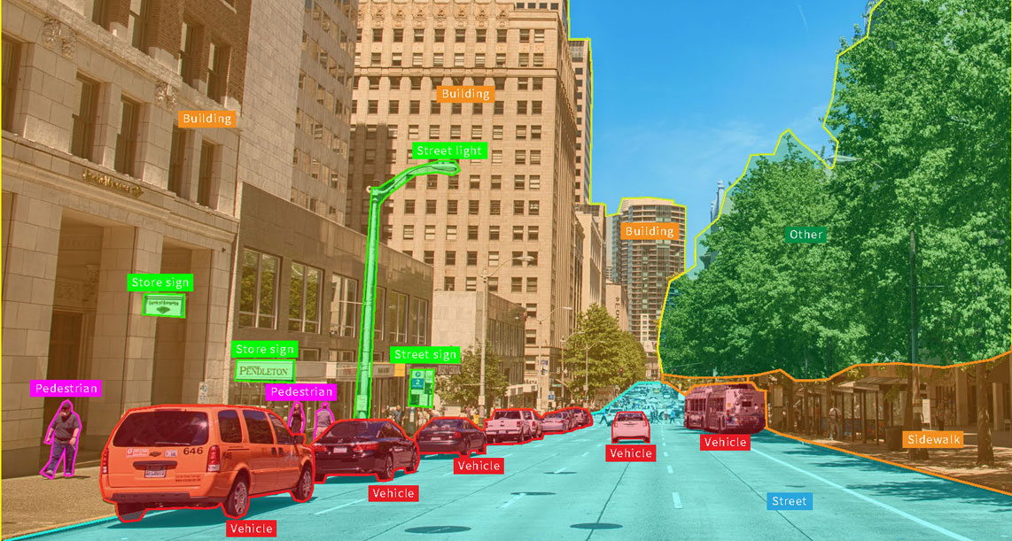

Another important application of AI comes under the form of Vision Systems. It is the ability of machines to visualize physical world and develop a perception about it. One of the common application of this can be seen in OCR.

1. **OCR**

OCR stands for **Optical Character Recognition**. It is the ability to understand text available on an image. This text can be handwritten as well. This saves a lot of time in manually typing out words after words.

Defense and Research - Computer Vision (CV) has helped tremendously in Defense activities as well. A Bomb-defuser robot eliminates human life risk and can be operated from a distance.

Similarly, Drones have helped in getting a bird’s eye on inaccessible regions. Robotics coupled with CV have made many exploration trips possible to regions like Antarctica.

1. **Talking Devices**

With Apple SIRI and Google Now, mobile users experienced a newer way of personalization.

This is where NLP (Natural Language Processing) is used extensively. AI as a field have come into many aspects of our lives and it will continue to do so.

QAS -

1. The exact working of Machine Learning related to Pattern Finding is known and easily understandable.?

No, it just throws patterns

1. Motion sensing have been extensively used in Kinect-based gaming. Will you consider it as a part of AI?

It provides a more humane approach of playing games

Proceed

1. Any future change in the ES can be done easily. State true or false.?

False

ES builds a Knowledge Base with the help of experts. If any condition or rule changes, it is very difficult to edit the same as corresponding decisions will also be affected.